Assignment | Day 4 | Cybersecurity | LetsUpgrade

***Name: Hardik Ajay Patil***

***Registered Email: hardik.patil048@gmail.com***

## Q 1. Find out the mail servers of the following domain:

1. **Ibm.com**
2. **Wipro.com**

**Answer:** *I am using the Windows Command Prompt in Pentester-Win-2016 virtual machine for solving this question*

### *ibm.com*

Step 1: Open cmd and type **nslookup** and press enter

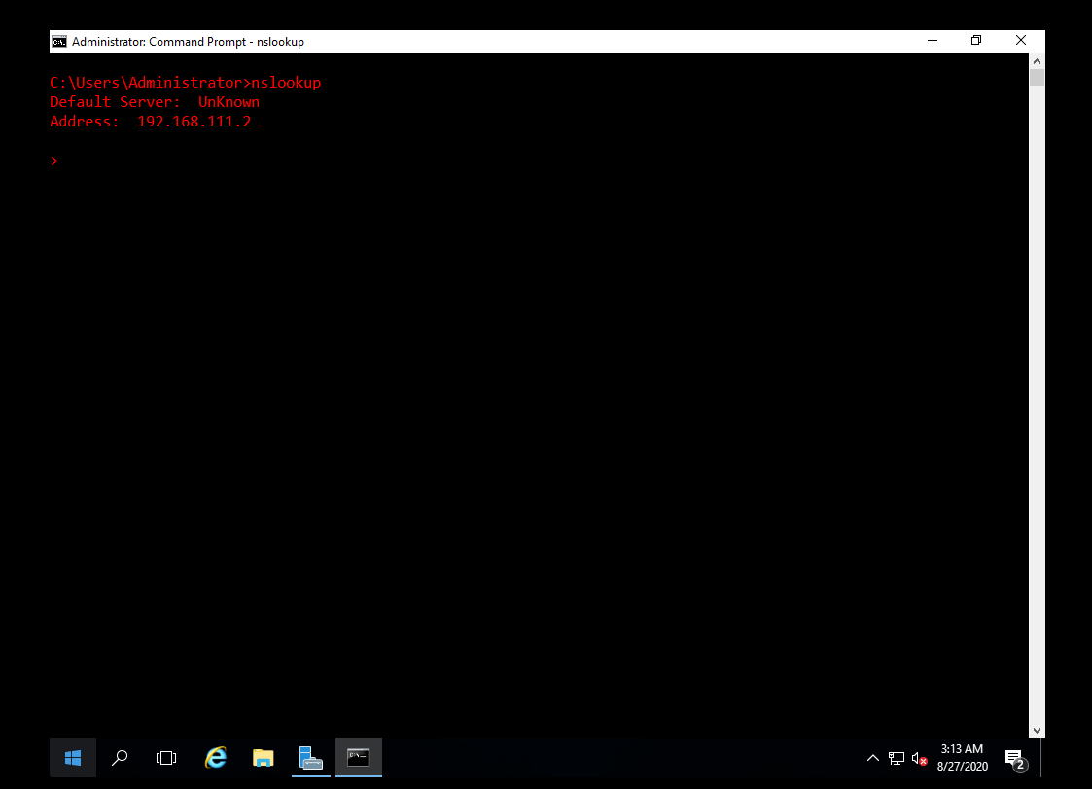

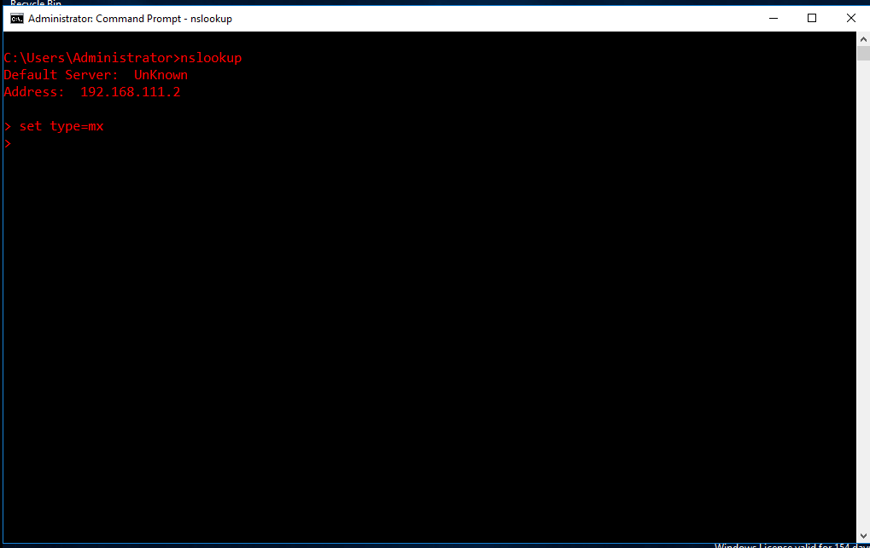

)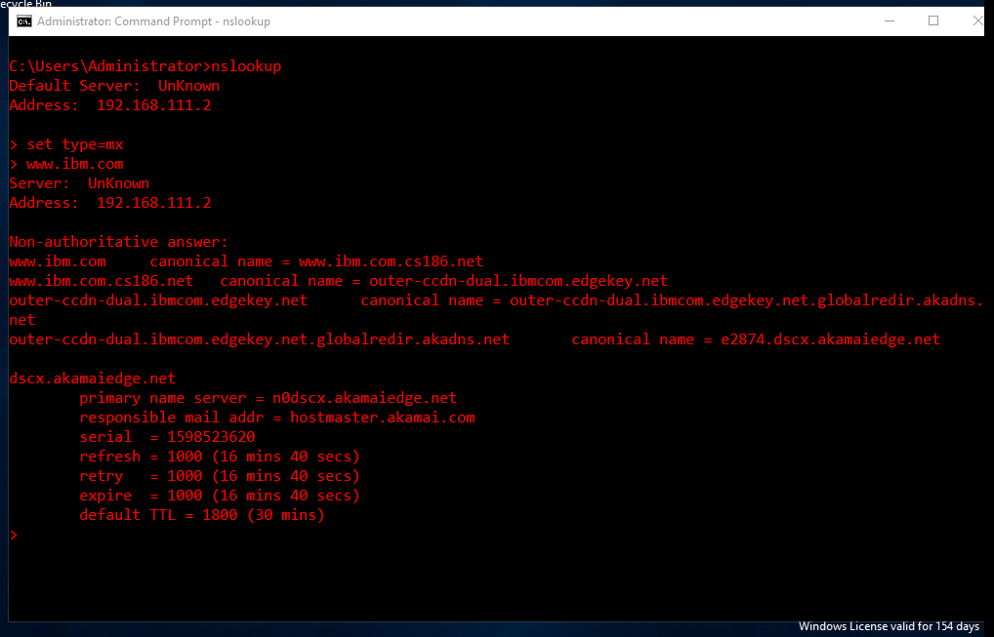

By this process we get the required mail server.

In this case the mail server is **hostmaster.akamai.com**



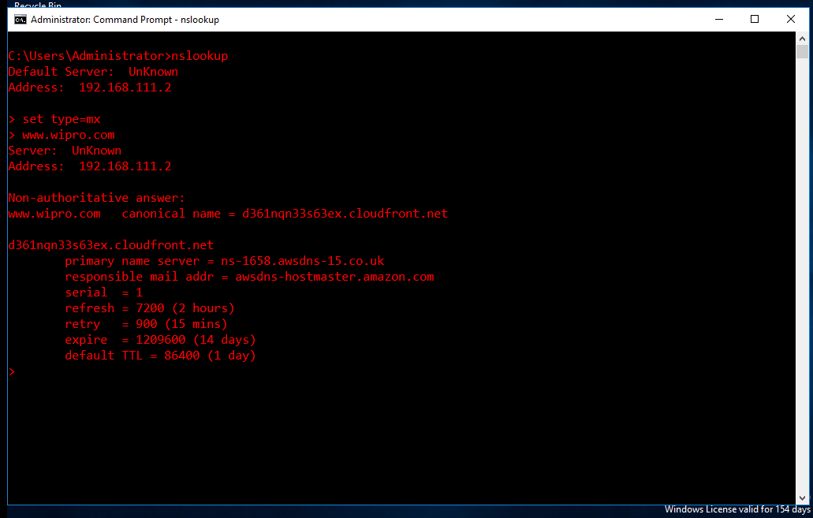

In this case the mail server is **awsdns-hostmaster.amazon.com**

**Q 2. Find the locations, where these email servers are hosted Answer:**

### *ibm.com*

Step 1: Open CMD >type and enter ***nslookup> set type=mx> ibm.com***

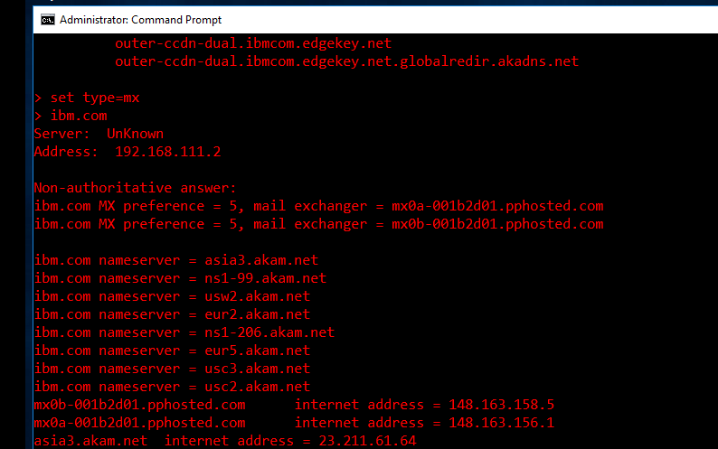

Step 2: Open a browser and go to [***https://tools.keycdn.com/geo?host=mx0a-001b2d01.pphosted.com***](https://tools.keycdn.com/geo?host=mx0a-001b2d01.pphosted.com) ***or any other IP location finder. Enter the IP address/hostname to get the results.***

**Address 1:** mx0b-001b2d01.pphosted.com

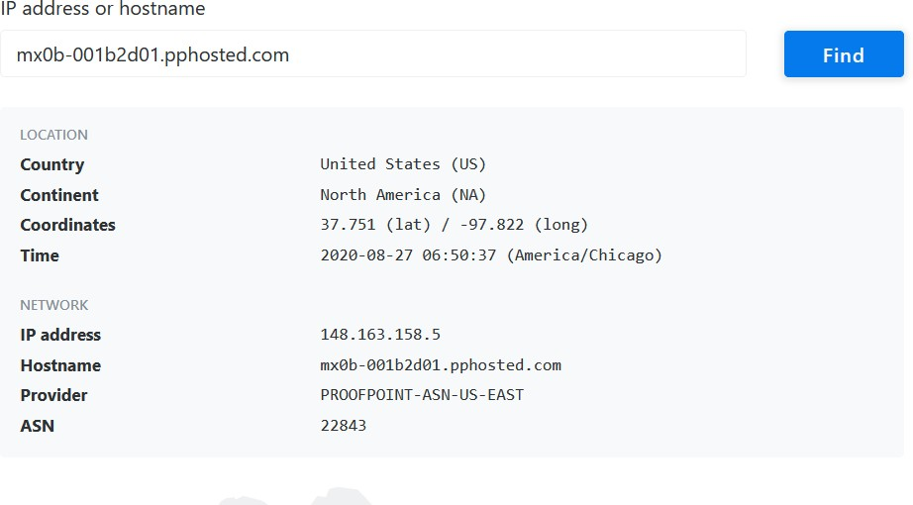

**Address 2:** mx0a-001b2d01.pphosted.com

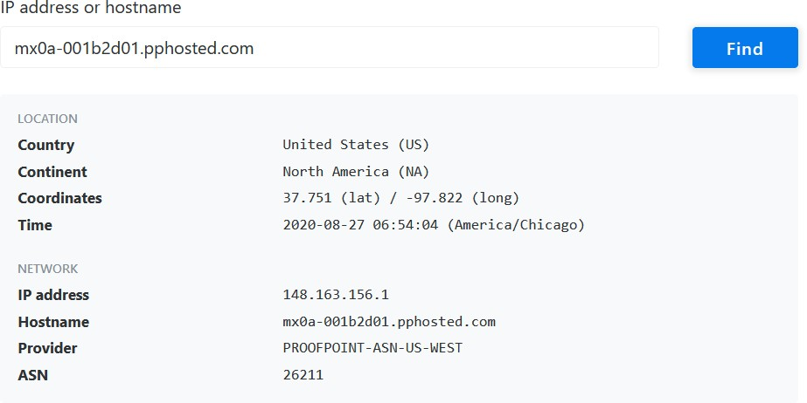

### *wipro.com*

Step 1: Open CMD >type and enter ***nslookup> set type=mx> wipro.com***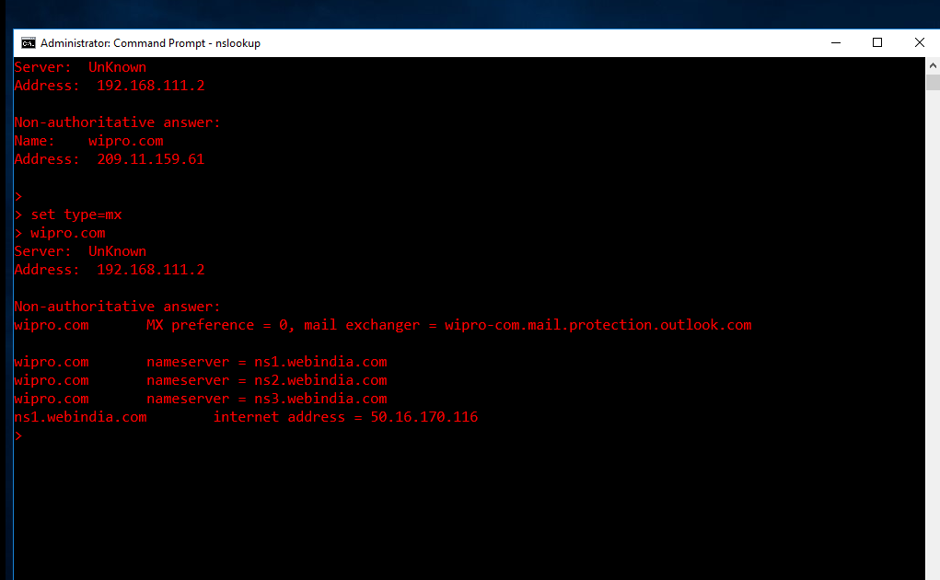

Step 2: Open a browser and go to [*https://tools.keycdn.com/geo?host=mx0a-001b2d01.pphosted.com*](https://tools.keycdn.com/geo?host=mx0a-001b2d01.pphosted.com) *or any other IP location finder. Enter the IP address/hostname to get the results.*

**Address:** wipro-com.mail.protection.outlook.com

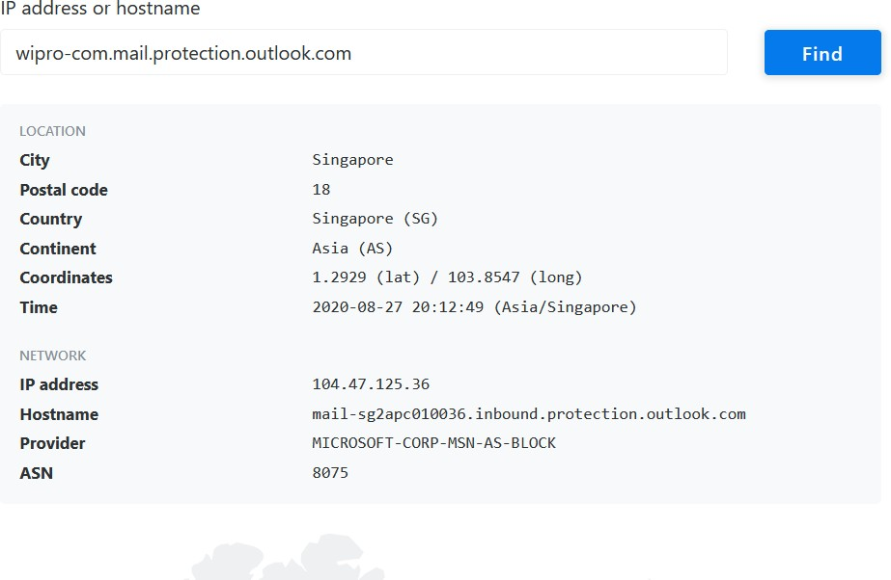

# Q 3. Scan and find out port numbers open 203.163.246.23

**Answer:**

Step 1: Open the terminal and go to administrator mode Command: sudo su –

(enter password and hit enter to enter administrator mode)

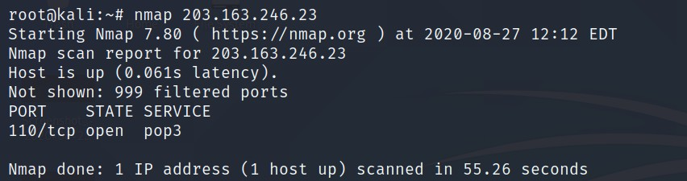

Therefore, one port is open as shown in the screenshot.

*nmap -v -A 203.163.246.23*

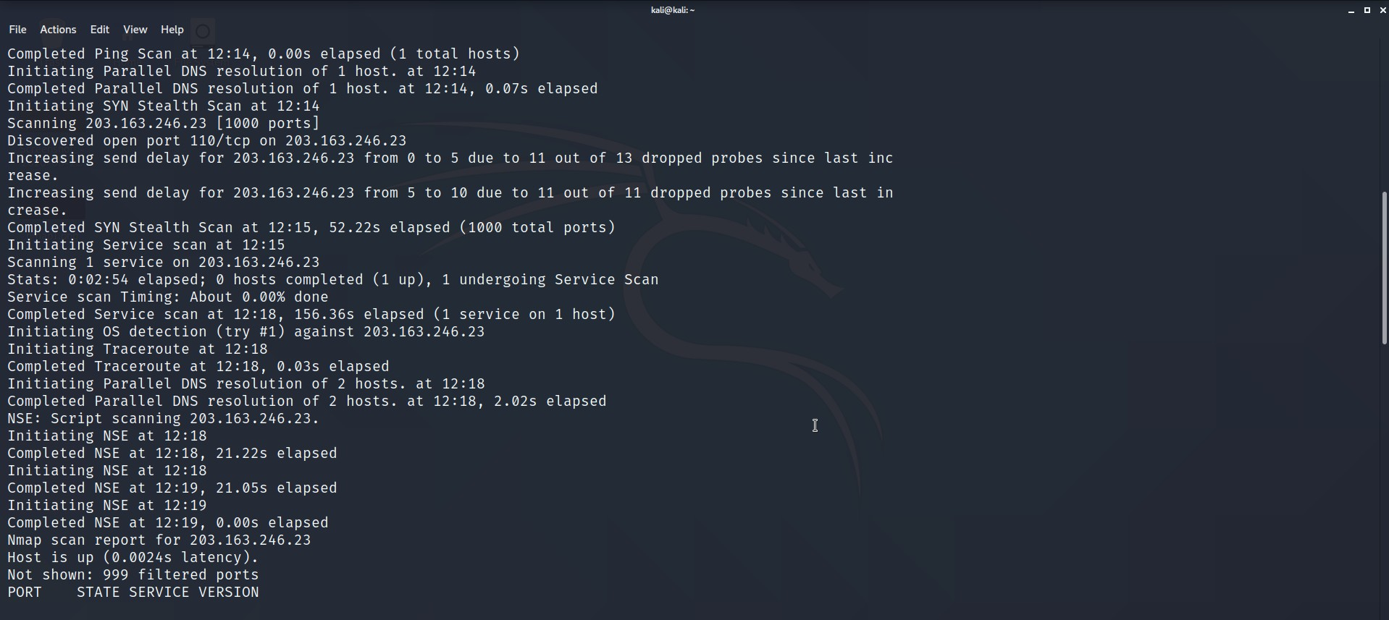

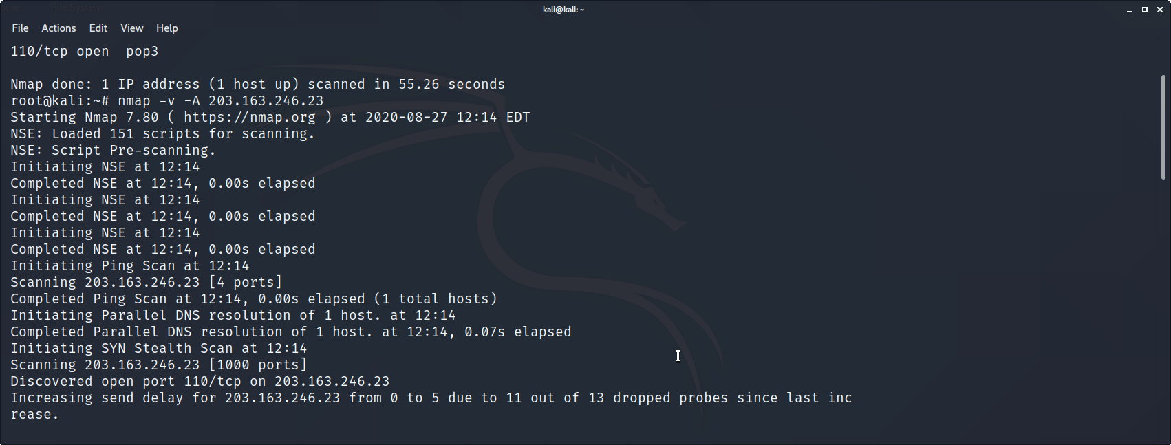

*Command: Nmap -Pn -sS 203.163.246.23*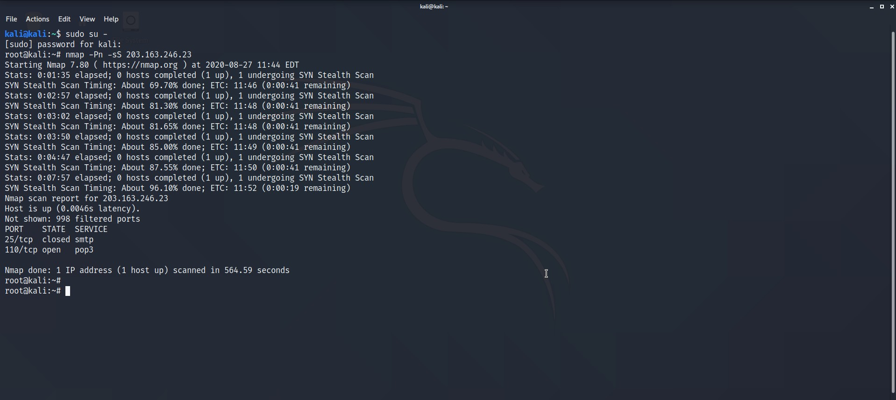

# Q 4. Install Nessus in a VM and scan your laptop/desktop for CVE

**Answer:**

Step 1: Open Pentester-Win 2016 VM and install Nessus in it and open it in a suitable browser. Step 2: Enter the Ipv4 address of your machine in the popup box and start Scanning.

Step 3: The scan is now running. Wait for few seconds until the scan is over.

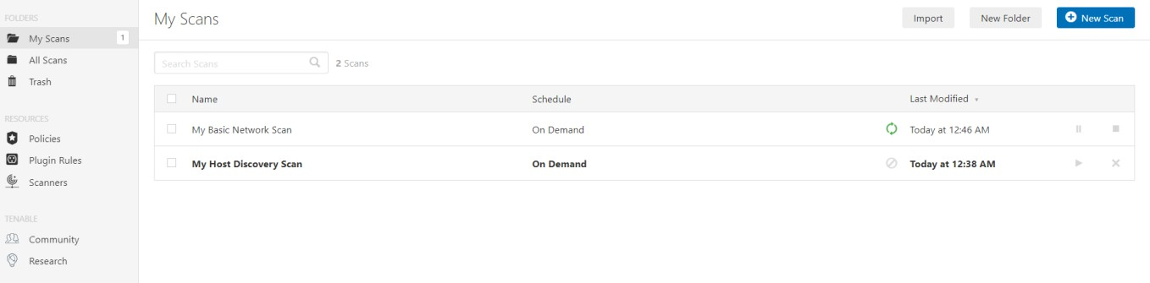

Step 4: Once the Scan is over, we can see the reports. (Click the Vulnerabilities tab to view the reports)

